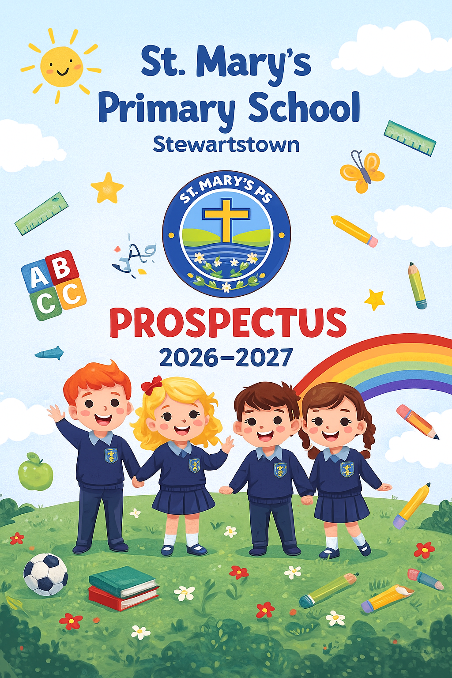

WELCOME
Welcome to St Mary’s Primary School, Stewartstown. Thank you for taking the time to read our school prospectus. We hope it gives you a clear sense of who we are, what we value, and the joyful, faith-filled learning experiences we offer every child entrusted to our care.
At St Mary’s, we believe that a primary school should be a happy, nurturing and inspiring place where every child is known as an individual and encouraged to shine. Rooted in our strong Catholic ethos, we work in partnership with families, the parish and the wider community to create a warm, welcoming environment where children feel safe, valued and supported.
Our new school motto reflects our commitment to developing the whole child:
Growing in Faith, Learning with Joy, Succeeding Together.
These words guide everything we do. We want all children to grow in confidence and character, to experience joy in their learning, and to develop the skills, knowledge and resilience they need to succeed both now and in the future.
We take pride in creating rich learning opportunities that spark curiosity, build independence and foster a lifelong love of learning. Our staff are committed, caring and dedicated to ensuring that every pupil reaches their full potential—academically, socially, emotionally and spiritually. We celebrate every achievement, big or small, and we work tirelessly to provide a high-quality education for all.
Choosing the right school for your child is one of the most important decisions you will make. We hope this prospectus gives you a meaningful insight into daily life at St Mary’s and the values that shape our school community. If you would like to visit us, we would be delighted to welcome you and show you our wonderful school in action.
We look forward to working with you and your child as we continue to grow, learn and succeed together.
St. Mary’s Primary School
22, West St. Stewartstown, Co Tyrone, BT71 5HT www.stmarysstewartstown.com
Tel: 028 87738388
Email: sdevlin329@c2kni.net

CATHOLIC ETHOS & SCHOOL AIMS
At St Mary’s Primary School, our Catholic faith is at the heart of everything we do. It shapes our relationships, guides our decisions and inspires us to provide a school environment rooted in love, respect, compassion and hope. We strive to live out the Gospel each day in our words, actions and attitudes, ensuring that every child feels cherished and supported.
Our school community is built on the belief that each child is a unique and precious individual, created by God with their own gifts, talents and potential. We work closely with our parish, families and wider community to nurture every child’s faith journey, helping them to grow spiritually as well as academically and socially.
Our motto captures the essence of our ethos:
Growing in Faith, Learning with Joy, Succeeding Together.
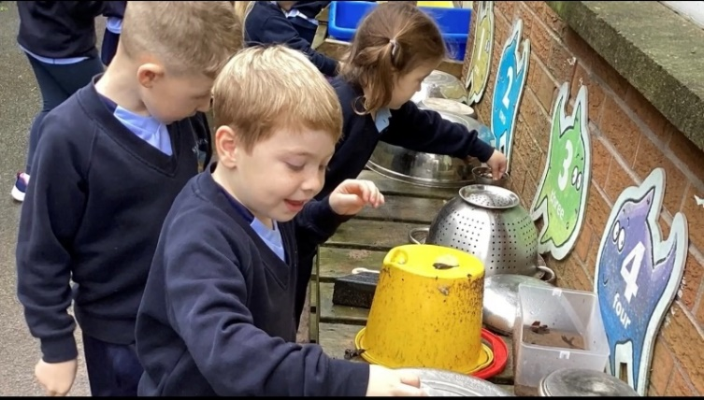
Faith is central to how we grow.
Joy fuels how we learn.
Togetherness shapes how we succeed.
Through daily prayer, assemblies, liturgical celebrations and sacramental preparation, our children learn the importance of kindness, forgiveness, gratitude and service. We encourage them to be confident, caring and responsible young people who make positive contributions to the world around them.

Our School Aims
At St Mary’s, we aim to:
- Provide a safe, welcoming and inclusive environment where every child feels valued and supported.
- Deliver high-quality teaching and learning experiences that inspire curiosity, creativity and confidence.
- Support the spiritual, moral, emotional and social development of all pupils.
- Celebrate every child’s achievements and encourage them to do their personal best.
- Build strong, trusting relationships with parents and families.
- Promote respect, responsibility and resilience in all aspects of school life.
- Encourage pupils to develop independence, problem-solving skills and a love of learning.
- Foster a strong sense of community where we work, learn and grow together in faith.
Through partnership, prayer and purposeful learning, we strive to help every child flourish and become the best version of themselves.

ABOUT OUR SCHOOL
St Mary’s Primary School is a happy, vibrant and child-centred school situated in the heart of Stewartstown. We are proud to serve our local community and to provide a warm, welcoming environment where all children feel safe, valued and supported.
Ours is a school built on strong relationships. We believe children learn best when they feel loved, respected and encouraged. Our dedicated staff work hard to create a caring atmosphere where children thrive academically, personally and spiritually. Every child is recognised as an individual with unique strengths, interests and potential, and we are committed to helping them flourish.
We operate composite classes, which are a natural and effective part of many successful primary schools in Northern Ireland. Composite teaching brings a number of benefits for pupils, including:
- opportunities for collaborative learning across age groups,
- increased independence and responsibility,
- more flexible grouping that allows teaching to be tailored to individual needs,
- enhanced leadership skills among older pupils, and
- a strong sense of teamwork and cooperation.
Children in composite classes thrive socially and academically as they learn from and support one another within a carefully structured and well-planned environment.
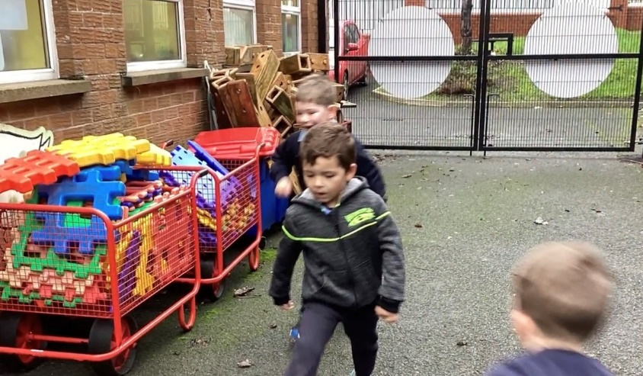
We are fortunate to have bright, modern facilities, well-resourced classrooms and a range of stimulating outdoor spaces. Outdoor learning is an important part of our school experience. From nature walks to practical investigations, our grounds provide rich opportunities for exploration, problem-solving and hands-on discovery. We believe that learning outdoors helps children develop confidence, resilience and a deeper connection with the world around them.
As a Catholic school, our values guide all aspects of school life. We promote kindness, respect, responsibility and resilience, encouraging children to make positive choices and show consideration for others. We celebrate diversity and inclusivity, and we welcome every child and family into our school community.
Our partnership with parents is central to everything we do. We value the trust parents place in us and work closely with families to support each child’s needs. Through open communication, shared expectations and a commitment to high standards, we strive to ensure all pupils reach their full potential and develop a lifelong love of learning.
We are proud of our pupils, proud of their achievements and proud of the joyful spirit that fills our school each day. At St Mary’s, children grow in confidence, build strong friendships and develop the foundations they need for a successful future.

THE SCHOOL DAY & PRACTICAL INFORMATION
A smooth, structured school day helps children feel secure, confident and ready to learn. At St Mary’s Primary School, we work hard to ensure that our daily routines support high-quality learning and create a positive start and finish to every child’s day.

School Day Structure
Our school day is designed to balance focused learning with opportunities for play, movement and social interaction. Children begin each morning with a calm, welcoming routine that helps them settle quickly and prepare for the day ahead.
The school opens in good time for children to organise their belongings and engage in early morning play. This supports independence, confidence and readiness for learning.
Break and lunch times provide opportunities for active play, outdoor exploration and social development. Staff supervise all play areas to ensure safety and positive interactions among pupils. We promote healthy play, cooperation and kindness during all free-play periods.

Attendance and Punctuality
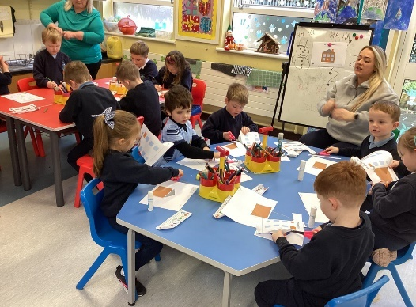
Regular school attendance is essential to every child’s progress and wellbeing. We work closely with families to support strong attendance and punctuality, and we encourage parents to keep the school informed of any absences or concerns.
We ask that children arrive on time each morning so they can fully benefit from the day’s learning. Good routines help children feel settled, confident and organised.

Uniform
Our school uniform promotes belonging, pride and equality. We expect pupils to wear their uniform neatly and with pride, helping to create a positive sense of community.
Uniform details can be found later in this prospectus. We appreciate the cooperation of all families in maintaining high standards of presentation.

Healthy Eating
We encourage healthy eating habits and promote nutritious choices throughout the school day. Children from P3-P7 are welcome to bring healthy snacks for break time, and school meals are available daily. Children in P1 and P2 are provided with their healthy snack daily. We aim to foster positive attitudes towards food and wellbeing from an early age.

Safety and Supervision
The safety of our children is our top priority. All areas of the school grounds are monitored by staff during arrival, break, lunch and home time. We have clear safeguarding procedures and ensure that all routines support the physical and emotional safety of our pupils.
We ask parents to support our safety measures by following drop-off and pick-up routines carefully and communicating promptly with the school if alternative arrangements are required.

Communication with Parents
Effective communication with families is central to the smooth running of school life. We keep parents informed through regular newsletters, the school app, parent-teacher meetings and individual updates when necessary. Parents are encouraged to contact the school with any concerns, questions or suggestions.

CURRICULUM & LEARNING
At St Mary’s Primary School, we offer a rich, engaging and inclusive curriculum that supports every child’s academic, social, emotional and spiritual development. Our teaching reflects the Northern Ireland Curriculum while placing strong emphasis on creativity, curiosity and high expectations for all learners.
We believe that children learn best when they feel valued, motivated and supported. Our curriculum is designed to nurture the whole child—developing skills, confidence, independence and a genuine love of learning.
We plan learning that is responsive to the needs, abilities and interests of all pupils. Through a balance of whole-class teaching, group work and individual support, we ensure children are appropriately challenged and supported.

Cross-curricular Skills:
Cross-curricular skills formally assessed | Thinking Skills & Personal Capabilities
Communication | Self-Management
Using Mathematics | Working with Others
Using Information and Communications Technology (I.C.T.) | Being Creative
 | Thinking, Problem solving and Decision Making
 | Managing Information
Our composite classes allow us to teach flexibly, group children according to ability and interest, and provide personalised learning across year groups. This helps pupils develop independence, leadership and strong cooperative skills while benefiting from a rich and varied learning environment.
We set individual targets for every pupil and monitor progress regularly. This helps us track learning closely, identify strengths and areas for development, and ensure that each child receives the support and challenge they need to thrive.

Literacy
Literacy has a central place in our curriculum, and we strive to develop confident, fluent and enthusiastic readers and writers.
Children experience:
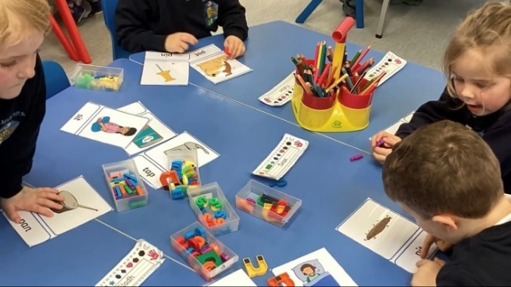
- Shared, guided and independent reading
- Daily phonics and spelling instruction
- Opportunities for creative and functional writing
- Storytelling, drama and oral language development
- Language-rich classrooms that promote vocabulary growth
We also use Accelerated Reader to motivate pupils, develop comprehension skills and foster a love of reading. This programme enables children to read at their own level and pace, while giving teachers valuable information to support each child’s progress.

Numeracy
Our Numeracy programme develops strong foundations in number, measures, shape, handling data, reasoning and problem-solving.
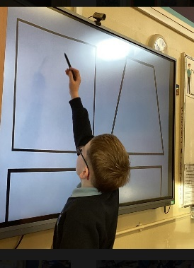
Children are encouraged to:
- Explore mathematical concepts practically
- Apply skills to real-life situations
- Work collaboratively and independently
- Build confidence through problem-solving
- Think critically and explain their ideas
We use Mathletics to support Numeracy learning both in school and at home. This interactive programme builds fluency, strengthens mental maths skills and develops children’s confidence through engaging activities and challenges.

World Around Us (WAU)
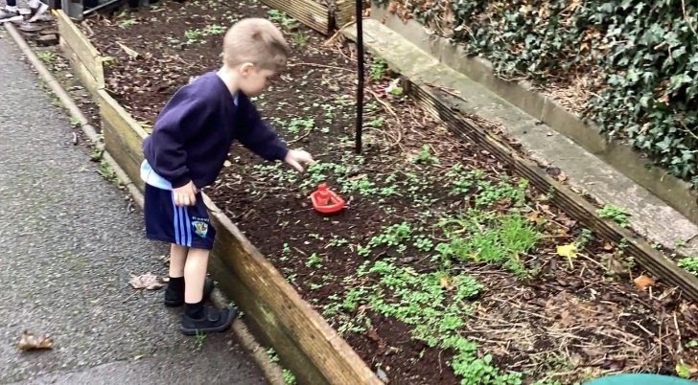
WAU brings learning to life through science, geography and history. Children develop enquiry skills through practical investigations, research and hands-on exploration.
Outdoor learning plays an important role in our WAU curriculum, helping children build resilience, curiosity and a deeper understanding of the world around them.

The Arts
Creativity thrives at St Mary’s. Children enjoy opportunities in:
- Art and design
- Music
- Drama
- Craft and creativity
We believe every child should experience the joy of expressing themselves and discovering their unique talents.

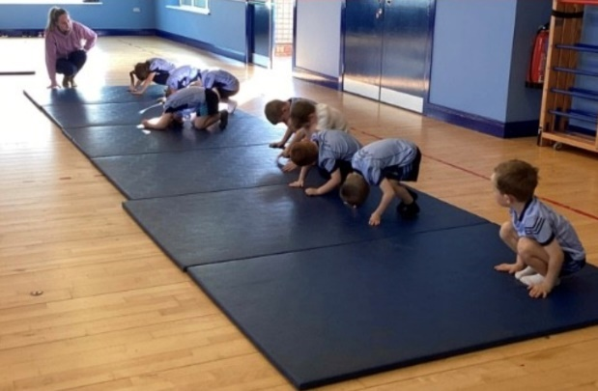
Physical Education (PE)
PE is an essential part of school life. Children participate in:
- Games
- Dance
- Gymnastics
- Outdoor activities
- Sports coaching and team events
We promote positive attitudes towards health, teamwork and physical activity.

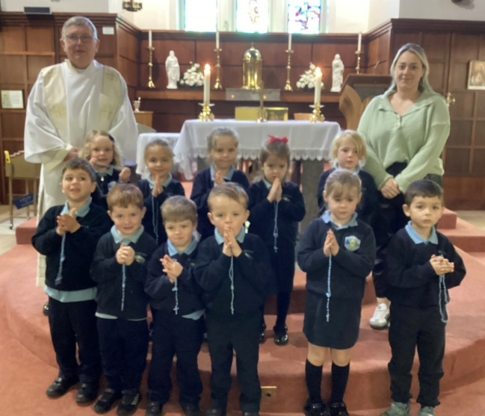
Religious Education (RE)
As a Catholic school, Religious Education underpins our curriculum. Through the Grow in Love programme, children learn about the life and teachings of Jesus, explore their faith, and take part in prayer and reflection.
Children also participate in parish celebrations, liturgical events and sacramental preparation. We aim to nurture compassion, kindness and a strong sense of belonging.

ICT & Digital Learning
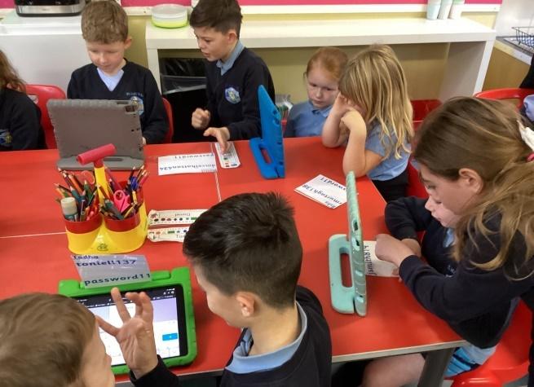
Children use ICT across all subjects to enhance learning and develop essential digital skills.
They learn to:
- Use digital tools purposefully
- Create, code and problem-solve
- Research and present information
- Behave responsibly and safely online
ICT builds confidence, independence and creativity in our learners.

PASTORAL CARE, SAFEGUARDING & WELLBEING
At St Mary’s Primary School, the pastoral care, wellbeing and safety of our pupils are at the centre of everything we do. We believe that children learn best when they feel secure, valued and supported, and we work hard to create an environment where every child feels loved, respected and able to flourish.
Our pastoral ethos reflects our Catholic values of kindness, compassion, respect and responsibility. We promote positive relationships, encourage empathy and help children develop confidence, resilience and self-belief.

Pastoral Care
We pride ourselves on knowing every child as an individual. Our staff take time to build meaningful relationships with pupils and families, creating a strong sense of belonging and trust. We celebrate achievements, support emotional wellbeing and provide encouragement and guidance whenever children face difficulties.
Children are taught strategies to manage their emotions, solve problems and develop healthy relationships. We promote a caring, cooperative school culture where positive behaviour is modelled, encouraged and celebrated.
To support individual emotional needs, we work closely with a Play Therapist, who provides targeted sessions for children who may benefit from structured therapeutic support. This approach helps children express themselves safely, build confidence and develop coping strategies.

Anti-Bullying & Restorative Practices
St Mary’s has a clear anti-bullying policy and a proactive approach to building a safe, respectful school environment. We teach children about friendship, kindness, inclusion and respect, and we encourage them to speak out if something is worrying them.
When difficulties arise, we use restorative practices to help children understand the impact of their actions, repair relationships and rebuild trust. This approach promotes empathy, responsibility and positive conflict resolution.
We aim to ensure that every child feels safe, supported and confident to ask for help.

Safeguarding
Safeguarding the children in our care is an absolute priority. St Mary’s follows the Department of Education’s safeguarding guidance and has clear policies and procedures in place to protect and support our pupils.
Our safeguarding team ensures that:
- All staff receive annual safeguarding and child protection training
- Concerns are responded to quickly, sensitively and in confidence
- Children know who they can talk to if they are worried
- Safety routines and procedures are firmly embedded throughout the school day
- We work effectively with external agencies when additional support is needed
We continually review and strengthen our safeguarding practices to ensure the highest standards of care and protection.

Wellbeing
Children’s wellbeing is central to our school life. We promote a positive, healthy approach to mental, emotional and physical wellbeing through daily routines, classroom practice and whole-school activities.
Wellbeing at St Mary’s includes:
- Supporting emotional regulation and resilience

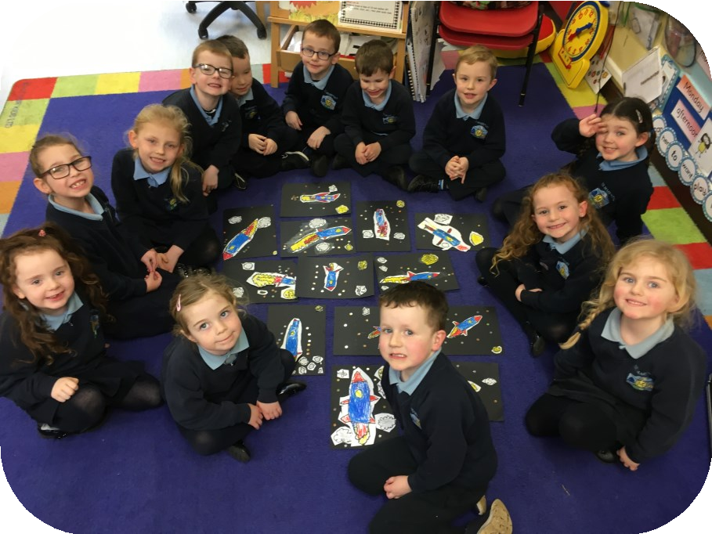
- Encouraging healthy friendships and positive play
- Providing opportunities for quiet reflection and prayer
- Encouraging active lifestyles and movement breaks
- Teaching children to recognise and manage their feelings
- Creating a safe environment where openness and honesty are encouraged
Our goal is to help children develop confidence, independence and a strong sense of personal worth.

Support for Additional Needs
We work closely with families, outside agencies and the Education Authority to meet the needs of pupils who require additional support. Through early identification, regular monitoring and tailored strategies, we ensure that every child—regardless of their needs or starting point—has the opportunity to succeed.
We are committed to inclusion and to providing the appropriate understanding, support and resources every child deserves.

HOME–SCHOOL PARTNERSHIP & COMMUNITY LINKS
At St Mary’s Primary School, we believe that strong relationships between home and school are essential for children to thrive. We value parents as partners in their child’s education and work closely with families to ensure that every child feels supported, encouraged and celebrated.

Working Together With Parents
We encourage open, honest and positive communication with parents. By sharing information, celebrating achievements and working collaboratively to address concerns, we create a shared understanding of how best to support each child.
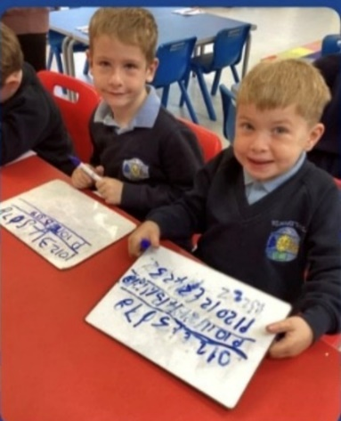
Our communication with parents includes:
- Regular newsletters and updates
- The school app for instant alerts and messages
- Parent–teacher consultations
- Progress reports and individual targets
- Invitations to school events, assemblies and celebrations
- Opportunities to meet with staff when needed
We value the trust parents place in us and always strive to build strong, respectful relationships.

Parents as Partners in Learning
We believe that learning continues beyond the classroom. Parents are encouraged to:
- Support homework routines
- Read regularly with their child
- Communicate concerns promptly
- Celebrate progress and effort
- Engage in school life and events
By working together, we can help every child reach their full potential.

Community Involvement
St Mary’s is proud to be at the heart of the Stewartstown community. We strengthen community spirit through:
- Parish partnerships and involvement in liturgical celebrations
- Links with local sports clubs and community organisations
- Participation in local events and initiatives
- Charity fundraising and outreach projects
- Collaboration with neighbouring schools where appropriate
These links enrich our pupils’ learning experiences, build confidence and help children understand the importance of community contribution.

Parent Teacher Association (PTA)
We are fortunate to have a dedicated and supportive PTA whose work brings tremendous benefits to our school. The PTA organises events, raises funds and creates wonderful opportunities for families to socialise and connect.
Their efforts help enhance school resources, support class projects and strengthen the sense of belonging within our school community.

Open-Door Ethos
We operate an open and supportive communication system. Parents are encouraged to contact the school whenever they have questions or need guidance. We aim to ensure that concerns are addressed promptly and sensitively, and that parents always feel listened to and respected.

EXTRA-CURRICULAR ACTIVITIES & ENRICHMENT
At St Mary’s Primary School, we believe that education extends far beyond the classroom. Our extra-curricular and enrichment opportunities help children develop their talents, build confidence, make friends and discover new interests. These experiences add joy, balance and variety to school life.

A Broad Range of Activities

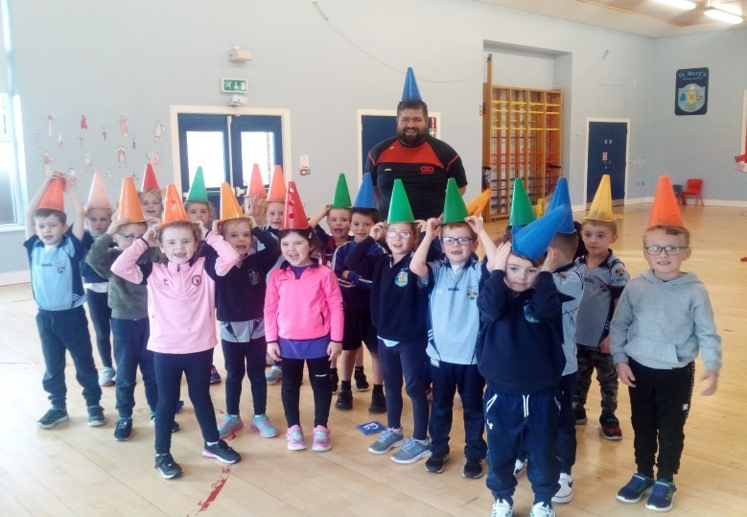
Throughout the year, we offer a variety of clubs and activities designed to support children’s physical, creative, social and personal development. These include:
- Urban Motion Dance
- AB Coaching (Sports Coaching)
- Traditional Music / Tin Whistle
- Gymnastics coaching
- Seasonal themed clubs and activity sessions
Children are encouraged to participate, try new things and discover what they enjoy most. Our range of clubs caters for different interests, personalities and strengths.
Children also take part in:
- Sports Day
- Sports competitions within local and regional networks
- Feiseanna, celebrating Irish culture, music and dance
These opportunities promote health, resilience, teamwork and confidence.

Creative, Cultural & Performing Arts
Creativity is a vibrant part of life at St Mary’s. Our pupils take part in:
- Traditional Music sessions
- Art and craft activities
- Singing and musical performance opportunities
- School celebrations and cultural events
We are incredibly proud of our:
- Annual Christmas Carol Service
- Bi-Annual School Production at the Craic Theatre
(a much-loved highlight for pupils, staff and families)
These events allow children to showcase their talents, develop performance confidence and experience the joy of working together toward a shared goal.

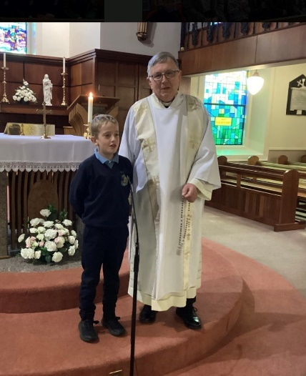
Faith & Community Activities
As a Catholic school, we participate in:
- Parish celebrations and feast-day liturgies
- Charity events and fundraising
- Community outreach initiatives
- Whole-school RE celebrations
We also hold special cultural events such as:
- Our St Patrick’s Day Céilí
- Seasonal celebrations throughout the year
Such events strengthen relationships within our school community and help children understand the value of service, faith and belonging.

Special Events & Enriching Experiences
We further enrich school life through:
- Educational visits and class trips
- Visitors and workshops in school
- Themed project weeks
- Creativity days and STEM experiences
- Whole-school celebrations and assemblies
- Our Halloween Dance, a favourite annual tradition
These experiences help make school life memorable, exciting and full of joy.

A Place for Every Child
We encourage all pupils to take part in activities that interest them. Participation in extra-curricular life helps children grow in confidence, develop new skills and nurture wellbeing. It strengthens friendships, supports emotional development and contributes to each child’s all-round growth.

ATTENDANCE, BEHAVIOUR & EXPECTATIONS
At St Mary’s Primary School, we set high expectations for attendance, behaviour and effort. We believe that children flourish when they attend school regularly, behave respectfully and are supported by consistent routines both at home and in school.
Our expectations are rooted in our Catholic values of respect, kindness, honesty and responsibility. We want every child to feel proud of their achievements and to play a positive role in their school community.

Attendance & Punctuality
Good attendance is essential for every child’s learning and wellbeing. Regular attendance ensures that children:
- Make consistent progress
- Build strong friendships
- Feel confident and secure in daily routines
- Develop positive attitudes towards school and learning
We ask parents to:
- Ensure children arrive punctually each morning
- Inform the school promptly of any absence
- Arrange appointments outside school hours where possible
- Contact the school if they need support with attendance
We monitor attendance regularly and work in partnership with families to address any concerns early.

Behaviour & Positive Conduct
At St Mary’s, we promote positive behaviour through encouragement, praise and clear expectations. We believe in fostering self-discipline, respect and responsibility.
Children are supported to:
- Treat others with kindness and respect
- Follow school rules and routines
- Listen carefully and try their best
- Make safe and sensible choices
- Resolve disagreements respectfully
Positive behaviour is celebrated throughout the school, helping children feel valued and motivated.

Promoting Respect & Responsibility
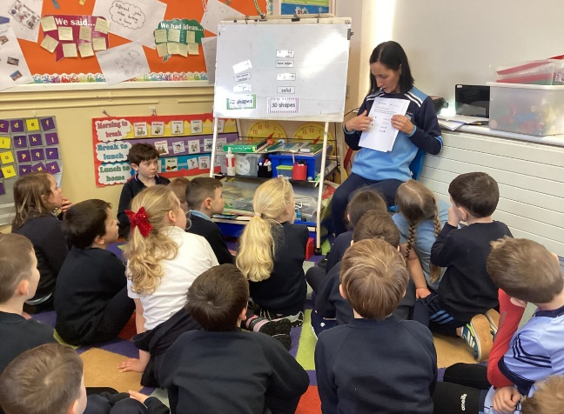
We teach pupils to understand their role in creating a safe, happy school environment. Through daily interactions, RE lessons, assemblies and pastoral support, children learn:
- To take responsibility for their actions
- To show empathy and care towards others
- To look after our school environment
- To recognise and celebrate differences
Our approach helps children grow into considerate, confident and responsible young people.
We believe in building relationships based on trust, shared expectations and mutual respect.

ADMISSIONS & ENROLMENT
Choosing a school for your child is one of the most important decisions a family will make, and we are delighted that you are considering St Mary’s Primary School, Stewartstown. We welcome applications from all families who wish for their child to experience a caring, inclusive and faith-filled education.

Admissions Process
Admissions to primary schools in Northern Ireland follow the procedures set out by the Education Authority (EA). Parents apply online during the annual admissions window, and decisions are made in line with the school’s published criteria.
Our admissions criteria are reviewed each year and are available:
- On the Education Authority website
- From the school office on request
We encourage parents to read these criteria carefully to ensure they understand how places are allocated.

Welcoming New Pupils
We are committed to making the transition into school as positive and reassuring as possible. When a place is offered, families receive:
- A welcome pack with key information
- Details about induction arrangements
- An opportunity to meet staff
- Information on settling routines and what children will need
We want every child to begin their journey at St Mary’s with confidence, excitement and a strong sense of belonging.

Induction & Settling In
Our induction programme helps children adjust gradually and comfortably to school life. During the early weeks, children:
- Become familiar with their new classroom
- Meet staff and classmates
- Learn school routines in a gentle, supportive way
- Build confidence through play-based learning
- Establish relationships with their peers and teachers
We also provide parents with guidance on how they can support their child during this important transition.

Admissions Throughout the Year
If families move into the area or seek a place mid-year, enquiries are always welcome. We are happy to discuss availability, provide a tour of the school, and support children joining us at any stage.

A Warm Welcome Awaits
At St Mary’s, we pride ourselves on being a school where every child is valued, respected and nurtured. We look forward to welcoming new families into our school community and supporting each child to grow, learn and succeed.

SCHOOL UNIFORM
At St Mary’s Primary School, our uniform is an important part of our school identity. It promotes pride, belonging and equality among all pupils, helping to create a positive and respectful learning environment. We ask for the support of all families in ensuring that children wear their uniform neatly and consistently.

School Uniform
Our uniform is practical, smart and designed to allow children to participate fully in school life. Pupils are expected to wear:
- Navy school sweatshirt or cardigan with school crest
- Light blue polo shirt with school crest
- Navy trousers, skirt or pinafore
- Navy tights or socks
- Black school shoes
We encourage children to take pride in their appearance and to look after their uniform.

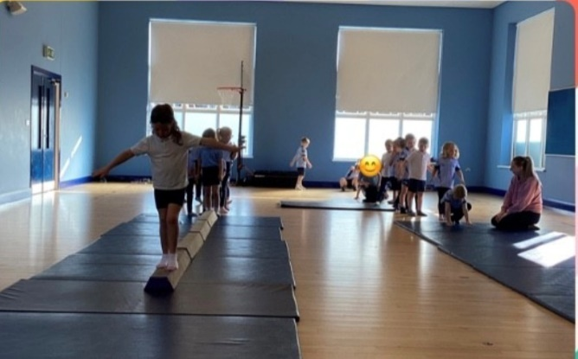
PE Uniform
For PE and physical activity, pupils should wear:
- Navy tracksuit bottoms or shorts
- White t-shirt
- Trainers suitable for sport
- School Jersey and/or shorts (optional)
On PE days, children may come to school wearing their PE kit if advised by their class teacher.

Jewellery & Hairstyles
For safety reasons, jewellery should not be worn in school, other than small stud earrings. Long hair should be tied back for PE and practical activities.
We appreciate the cooperation of parents in supporting these guidelines.

Looking After Uniform
We ask parents to label all items of clothing clearly with their child’s name. This helps prevent lost items and allows us to return found items quickly.

SCHOOL MEALS, HEALTHY EATING & BREAKTIME
Healthy eating and positive attitudes towards food are an important part of life at St Mary’s Primary School. We encourage children to develop healthy habits from an early age and to enjoy nutritious foods that support learning, concentration and wellbeing.

School Meals
School dinners are prepared fresh each day in our kitchen and offer a balanced, healthy meal for pupils. Menus follow the nutritional standards set by the Department of Education and rotate on a regular basis.
Children may choose a school dinner or bring a packed lunch from home. We ask that packed lunches reflect healthy eating guidelines and avoid sugary snacks or drinks. Water is encouraged throughout the day.
Parents are informed in advance of menu updates, themed meal days and any changes to dinner arrangements.

Healthy Break Café — Foundation Stage
In the Foundation Stage classroom, we operate a Healthy Break Café, where children are gently encouraged to make positive food choices, develop independence and enjoy a social snack-time routine.
The café helps children:
- explore new foods in a relaxed way
- learn the importance of healthy eating
- practise manners and social skills
- make independent choices
This routine supports early social development and encourages children to see healthy eating as enjoyable and rewarding.

Breaktime Snacks
Across the school, we encourage healthy break choices. Suitable snacks include:
- Fresh fruit
- Vegetables
- Bread-based options (e.g. toast, soda bread)
- Yoghurts or cheese portions
Crisps, sweets, chocolate bars and fizzy drinks are not permitted at break.
Healthy eating is further reinforced through our PDMU curriculum, where children learn about caring for their bodies, making good choices and developing healthy lifestyles.

Food Allergies & Medical Needs

It is essential that parents inform the school of any allergies or dietary requirements. Staff are trained to support children with specific needs, and appropriate care plans are put in place where required.
We maintain strict procedures to ensure that children with allergies are kept safe, particularly in shared eating areas.

Water & Hydration
All children are encouraged to bring a water bottle to school each day. Regular hydration supports concentration, energy levels and overall wellbeing.

Breaktime Routines
Break and lunch times are important opportunities for play, movement and social interaction. Staff supervise all playground areas to ensure safety and promote positive, inclusive play.
Children are encouraged to:
- Play cooperatively
- Include others
- Try new activities
- Use equipment safely
Outdoor play takes place in most weather conditions, so appropriate coats and footwear are essential.
We believe that breaktime contributes to happier, more confident learners and helps develop friendships and social skills.

SPECIAL EDUCATIONAL NEEDS (SEN) & INCLUSION
At St Mary’s Primary School, we are committed to providing an inclusive, nurturing environment where every child is supported to reach their full potential. We recognise that all children are unique, and some may require additional support with aspects of their learning, communication, behaviour, social development or emotional wellbeing.
We follow the SEN Code of Practice and work closely with parents, staff and external professionals to ensure that children’s needs are identified early and supported effectively.

Early Identification & Intervention
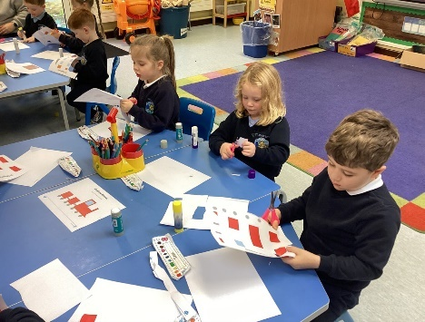
We monitor progress closely across the school and identify concerns as early as possible. When a child requires additional help, support is put in place promptly and reviewed regularly. This may include:
- targeted small-group work
- individual support
- differentiated teaching and learning
- additional classroom strategies
- support with communication or emotional regulation
We believe that early, compassionate intervention makes a significant difference to long-term progress and confidence.

Working in Partnership With Parents
Parents are central to the SEN process. We value the insights families bring and work together openly and supportively. Parents are informed of concerns, involved in decision-making and kept updated through meetings, reviews and regular communication.
Our aim is always to work collaboratively in the best interests of the child.

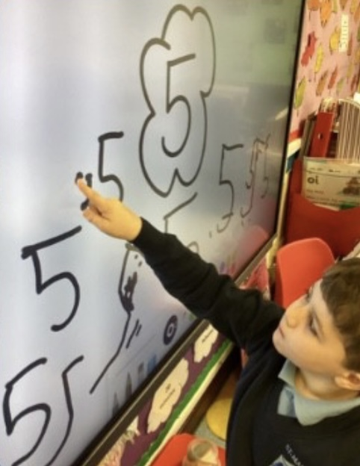
Support From Outside Agencies
When appropriate, we liaise with external professionals such as:
- Educational Psychologists
- The Education Authority SEN Support Team
- Speech and Language Therapists
- Occupational Therapists
- Behaviour Support
- Health and Social Care professionals
These partnerships help us better understand each child’s needs and tailor support accordingly.

Personalised Support & Planning
Where required, children may have:
- Personalised Learning Plans (PLPs)
- specific targets in Literacy, Numeracy, social or emotional development
- structured support within or beyond the classroom
- adaptations to teaching methods or resources
- emotional or behavioural support strategies
Targets are reviewed regularly, with progress monitored closely and shared with parents.

Inclusive Practice
In St Mary’s, inclusion is not just a policy — it is part of our ethos. We strive to ensure that all children:
- feel valued and included
- participate fully in school life
- experience success and achievement
- learn in a supportive, understanding environment
We promote empathy, acceptance and kindness throughout the school community

Emotional Health & Wellbeing
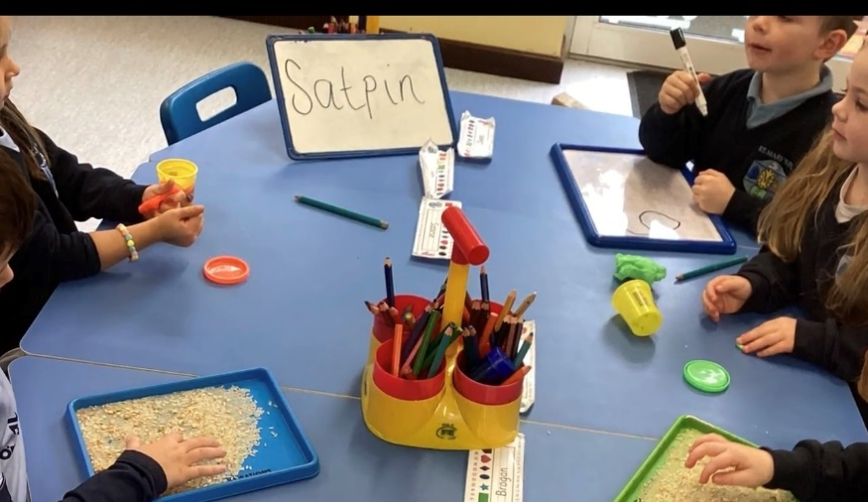
For children who need additional emotional or therapeutic support, we can provide access to a Play Therapist, who works with children to help them express feelings, process experiences and develop coping skills in a safe, child-led environment.
This nurturing support complements our pastoral care system and ensures children feel understood and supported.

A Supportive, Child-Centred Approach
Our goal is to help every child develop confidence, independence and a sense of belonging. We are committed to ensuring that all pupils — regardless of their needs — are supported to grow academically, socially and emotionally, and to experience joy, success and pride in their achievements.

FAITH LIFE, SACRAMENTAL PREPARATION & PARISH PARTNERSHIP
As a Catholic school, faith is at the heart of life at St Mary’s. Our mission — Growing in Faith, Learning with Joy, Succeeding Together — guides how we learn, how we support one another and how we celebrate our Christian values each day.

Faith in Daily School Life
Children experience faith naturally through:
- daily prayers and reflections
- assemblies and class worship
- celebration of feast days and liturgical seasons
- acts of kindness, respect and service
We encourage pupils to live out Gospel values in their words and actions.

Grow in Love Programme
All classes follow the Grow in Love Religious Education programme, which helps children grow in understanding of:
- Scripture
- prayer and worship
- Christian values
- the Sacraments
- the life of Jesus and the Church
The programme is joyful, engaging and age-appropriate.

Parish Partnership
We enjoy a strong relationship with our parish and local clergy. Children take part in parish Masses, liturgical celebrations and charity events, helping strengthen their sense of belonging within the faith community.

Sacramental Preparation
Working closely with families and the parish, we prepare children reverently and confidently for the Sacraments of:
- First Reconciliation
- First Holy Communion
- Confirmation
These special milestones are celebrated with great pride and joy across the whole school community.
POLICIES, PROCEDURES & ADDITIONAL INFORMATION
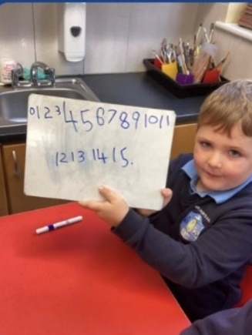
St Mary’s Primary School is committed to maintaining high standards in all areas of school life. We have clear policies and procedures that ensure the safety, wellbeing and effective education of every child in our care. Key policies are available from the school office or on our website, and parents are welcome to request further information at any time.

Safeguarding & Child Protection
Safeguarding is our highest priority. Our Child Protection Policy outlines how we protect children, respond to concerns and work with parents and external agencies. All staff are trained annually and follow procedures in line with the Department of Education guidance.
If a parent has a concern about a child’s safety or wellbeing, they should contact the Designated Teacher or the Principal immediately. Clear information about our safeguarding team is displayed throughout the school.

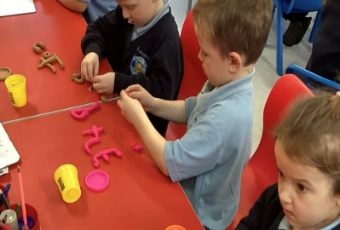
Behaviour & Discipline
Our Behaviour Policy promotes respect, responsibility and positive relationships. We focus on praise, encouragement and restorative practices. We expect children to follow our school rules and treat others with kindness and respect. Parents are kept informed of concerns and involved in supporting positive behaviour when needed.

Concerns & Complaints
We encourage parents to communicate openly with us. If a concern arises:
- Parents should first speak with the class teacher.
- If further clarification is needed, the Principal is available to discuss the matter.
- If the issue remains unresolved, the school’s Complaints Procedure can be followed.
We aim to resolve concerns promptly, sensitively and in partnership with families.

Attendance & Absence
Good attendance is essential for children’s progress and wellbeing. Parents are asked to:
- Contact the school on the morning of any absence
- Arrange appointments outside school hours where possible
- Support punctuality and daily routines
Persistent or unexplained absences may be monitored in line with EA guidance.

Medical Information
Parents should inform the school of any medical conditions or allergies. Medication can only be administered when agreed and documented through the appropriate forms. Care plans are created for children who require ongoing medical support.

Health & Safety
We follow strict health and safety procedures to ensure a safe environment for pupils, staff and visitors. Regular risk assessments, supervision routines and emergency drills are carried out.
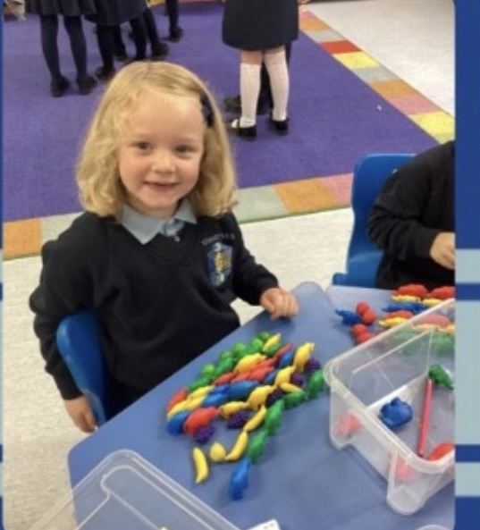
Parents can support us by:
- following drop-off and pick-up routines
- using designated entrances
- ensuring children have suitable clothing for outdoor learning and breaktime

Data Protection
St Mary’s complies with GDPR regulations. Information is stored securely and used only for educational, administrative or safeguarding purposes. Parents have the right to access or request corrections to their child's information.

Communication
We keep families informed through:
- the school app
- newsletters
- text alerts
- parent meetings
- the school website
Open communication ensures we work together effectively for the benefit of every child.

FINAL MESSAGE
Thank you for taking the time to read our school prospectus. We hope it has given you a clear and heartfelt picture of life at St Mary’s Primary School, Stewartstown.
At St Mary’s, we are committed to creating a school where every child feels safe, valued and inspired to be the very best they can be. Our new motto — Growing in Faith, Learning with Joy, Succeeding Together — captures the essence of who we are and what we strive for each day. We believe in nurturing the whole child through faith, strong relationships, high-quality teaching and joyful learning experiences.
We are proud of our pupils, our dedicated staff and the strong partnership we share with families and our parish community. Together, we create a warm, caring and ambitious environment where children develop confidence, resilience and a lifelong love of learning.
Choosing a school for your child is an important decision. If you would like to know more, we warmly invite you to contact us, arrange a visit or speak to a member of staff. We would be delighted to welcome you and show you the wonderful community that makes St Mary’s such a special place.
We look forward to the possibility of welcoming your child to St Mary’s and supporting them as they grow, learn and succeed with us.

Mrs Shaunagh Devlin
Principal
